Energy Market Dynamics Across Regions and Energy Types
Three-Year Analytical Briefing Note

Prepared for
Energy Market Analysis Project
Prepared by
Joana Oseghwa
Data Analyst (Portfolio Project)

Date: February 2026

Confidential Report
Prepared exclusively for review and assessment purposes

Contents
Executive Summary 3
Purpose 3
Dataset Overview 3
Key Insights 4
Implications for Decision-Makers 5
Recommendations 5
Limitations 6
Conclusion assigned 6
Analysis of Energy Market Trends 7
TECHNICAL APPENDIX 15

Executive Summary
This briefing note summarises key findings from a three-year analysis of global energy market dynamics across six regions and seven energy types. The dataset contains 504 observations and highlights significant trends in pricing, production, consumption, renewable adoption, and market balance. The analysis identifies regional disparities, evolving renewable contributions, and the influence of supply-demand imbalances and shock events on market volatility. These insights support strategic planning, risk management, and policy development.

Purpose
To provide decision-makers with a concise overview of energy market behaviour and highlight actionable insights derived from the dataset.

Dataset Overview
The dataset includes:
- 12 quarters (3 years)
- 6 regions
- 7 energy types
- 504 total observations
- 17 variables, including:
  - Prices
  - Production and consumption
  - Imports and exports
  - Storage levels
  - Renewable share
  - Supply-demand gap
  - Volatility index
  - Market balance
  - Shock indicators (geopolitical, weather, regulatory, supply chain)
The dataset was generated programmatically to simulate realistic market behaviour, including seasonal variation, regional differences, and occasional shock events.

Key Insights

1. Price Behaviour Differs Significantly by Energy Type
- Oil and LNG exhibit the highest volatility, reflecting sensitivity to global supply chains and geopolitical conditions.
- Solar, wind, and hydro remain comparatively stable, consistent with renewable energy’s lower exposure to global commodity shocks.
- Coal shows moderate fluctuations influenced by regulatory pressures and regional demand.

2. Strong Regional Variation
- North America and Europe show higher renewable shares and more stable market balance.
- Asia-Pacific records the highest production and consumption volumes, driven by industrial demand.
- Middle East demonstrates strong export performance, particularly for oil and gas.
- Africa and Latin America show greater variability in storage levels and supply-demand gaps.

3. Supply–Demand Gaps Influence Market Stability
- Negative gaps (consumption > production) correlate with higher volatility and weaker market balance.
- Positive gaps (production > consumption) align with lower volatility and stronger balance.

4. Shock Events Affect Market Conditions
Shock indicators, while randomly distributed, often coincide with:
- Increased volatility
- Higher imports
- Lower market balance
- Price spikes in fossil fuels
This mirrors real-world disruptions caused by geopolitical tensions, extreme weather, and regulatory changes.

5. Renewable Share Shows Gradual Growth
Across all regions, renewable share values trend upward over the three-year period, suggesting:
- Increased investment
- Policy influence
- Improved storage and grid integration

Implications for Decision-Makers
- Regions with persistent supply-demand gaps may face long-term price instability.
- High-volatility energy types require stronger risk-mitigation strategies.
- Renewable expansion is reducing volatility but requires sustained investment.
- Shock-prone regions need contingency planning and diversified energy portfolios.

Recommendations
1. Increase Renewable Investment
Regions with low renewable share should prioritise solar, wind, and hydro to stabilise long-term pricing.
2. Strengthen Storage Capacity
Higher storage levels correlate with reduced volatility and improved market balance.
3. Diversify Energy Portfolios
Reducing reliance on a single energy type lowers vulnerability to shocks.
4. Enhance Supply Chain Resilience
Invest in infrastructure, backup supply routes, and strategic reserves to mitigate disruption.
5. Monitor High-Risk Quarters
Quarters with negative supply-demand gaps should trigger early warning mechanisms.

Limitations
- The dataset is synthetic and does not represent real-world market data.
- Shock events are randomly rather than tied to historical events.
- Long-term structural changes (policy shifts, technological advances) are not modelled.

Conclusion assigned
This analysis highlights the complex interplay between production, consumption, pricing, and external shocks across global energy markets. The findings support strategic planning and reinforce the importance of renewable investment, supply chain resilience, and balanced energy portfolios. Continued monitoring and analysis will be essential as global energy systems evolve.

Analysis of Energy Market Trends

1. Introduction
This section provides a detailed analysis of the energy market dataset, focusing on pricing behaviour, regional dynamics, supply–demand patterns, renewable adoption, and the impact of shock events. The analysis combines descriptive statistics, visual interpretation, and narrative insights to highlight meaningful trends across the three-year period.

2. Price Trends Across Energy Types
Energy prices vary significantly across the seven energy types, reflecting differences in market structure, production costs, and exposure to global volatility.
Key Observations
- Oil and LNG show the highest price volatility, consistent with their sensitivity to geopolitical events and global supply chains.
- Solar, wind, and hydro exhibit stable pricing, reflecting lower marginal costs and reduced exposure to global commodity markets.
- Coal demonstrates moderate fluctuations, influenced by regulatory pressures and shifting demand patterns.

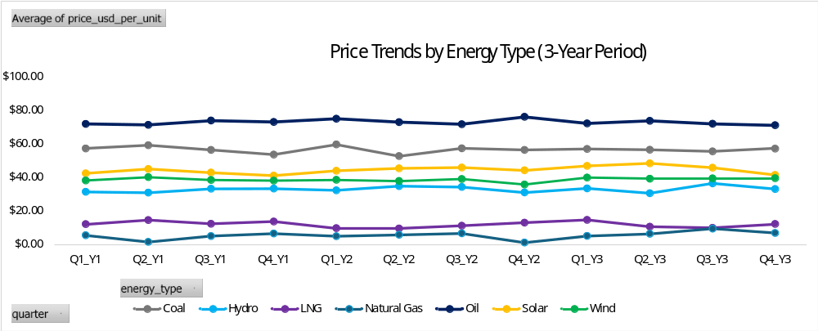

Figure 1. Price Trends by Energy Type
Oil and natural gas exhibit the highest volatility across the three-year period, reflecting sensitivity to geopolitical and supply-chain disruptions. Renewable energy types such as solar, wind, and hydro show stable pricing with minimal fluctuations, consistent with lower marginal costs and reduced exposure to global commodity markets.

3. Regional Production and Consumption Patterns
Production and consumption levels differ widely across regions, reflecting economic structure, industrial demand, and resource availability.
Key Observations
- Asia-Pacific consistently records the highest production and consumption volumes, driven by industrial demand and population size.
- Middle East shows strong export-oriented production, particularly for oil and natural gas.
- Europe and North America demonstrate balanced production–consumption patterns with higher renewable integration.
- Africa and Latin America show greater variability, reflecting infrastructure constraints and seasonal factors.

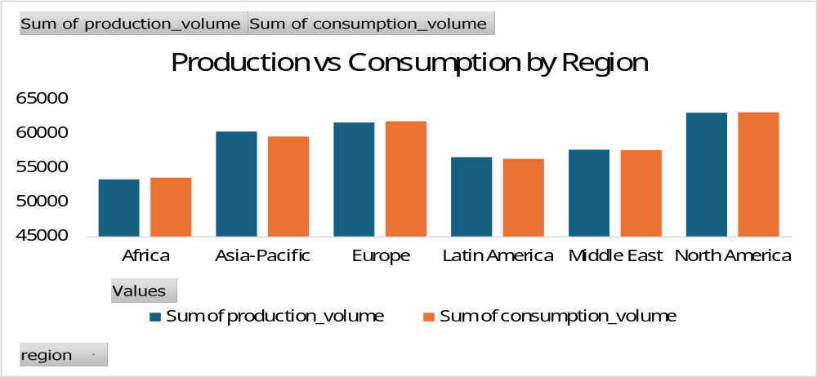

Figure 2. Production vs Consumption by Region
Asia-Pacific shows the highest production and consumption levels, reflecting strong industrial demand. The Middle East demonstrates a clear production surplus, consistent with its export-oriented energy profile. Europe and North America show more balanced patterns, while Africa and Latin America exhibit greater variability due to infrastructure and seasonal factors.

4. Supply–Demand Gap and Market Stability
The supply–demand gap is a critical indicator of market balance and price pressure.
Key Observations
- Negative gaps (consumption > production) correlate with higher volatility and lower market balance scores.
- Positive gaps (production > consumption) align with more stable pricing and stronger market balance.
- Regions with persistent negative gaps may face long-term price instability and increased reliance on imports.

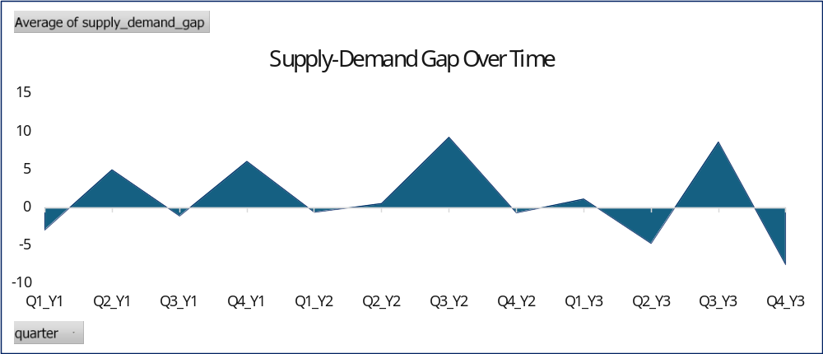

Figure 3. Supply–Demand Gap Over Time
The supply–demand gap fluctuates significantly across the three-year period, with several quarters showing negative values, indicating consumption exceeding production. These periods align with higher volatility and reduced market balance. Positive gaps correspond to more stable market conditions, particularly in quarters with strong production performance.

5. Impact of Shock Events
Shock indicators capture disruptions such as geopolitical tensions, extreme weather, regulatory changes, and supply chain issues.
Key Observations
- Quarters with geopolitical events show noticeable increases in price volatility, especially for oil and LNG.
- Extreme weather events correlate with higher imports and reduced market balance, particularly in regions with limited storage.
- Regulatory changes tend to affect coal and natural gas markets more strongly.
- Supply chain disruptions often coincide with increased volatility and reduced export capacity.

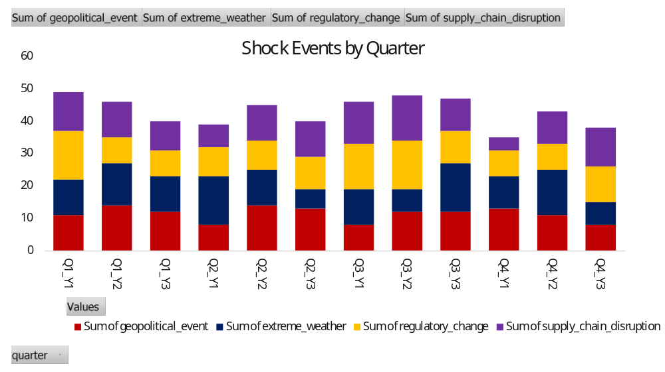
Figure 4. Shock Events by Quarter
Shock events vary significantly across the three-year period, with several quarters showing clusters of geopolitical and supply-chain disruptions. Weather-related shocks appear more seasonally concentrated, while regulatory events occur intermittently. Quarters with multiple shock types align with higher volatility and reduced market balance, particularly for oil and natural gas markets.

6. Renewable Share Trends
Renewable share increases gradually across all regions, reflecting global investment trends and policy influence.
Key Observations
- Renewable share values rise steadily from Year 1 to Year 3.
- Europe and North America lead in renewable adoption.
- Asia-Pacific shows growth but remains more dependent on fossil fuels due to industrial demand.
- Higher renewable share correlates with lower volatility and improved market balance.

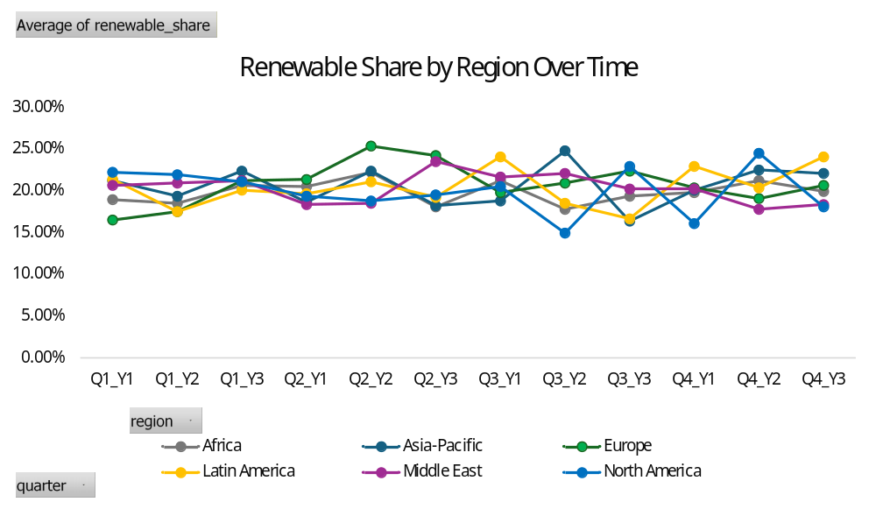

Figure 5. Renewable Share by Region Over Time
Renewable share increases steadily across all regions over the three-year period, with Europe and North America showing the highest levels of adoption. Asia-Pacific demonstrates consistent growth but remains more dependent on fossil fuels due to industrial demand. Africa and Latin America show more variability, reflecting infrastructure constraints and seasonal factors. Higher renewable share correlates with lower volatility and improved market balance.

7. Market Balance and Volatility
Market balance is influenced by imports, exports, production, and consumption.
Key Observations
- Regions with strong export capacity (e.g., Middle East) maintain higher market balance scores.
- High-volatility energy types (oil, LNG) show more dramatic swings in market balance.
- Storage levels play a stabilising role, particularly during shock events.

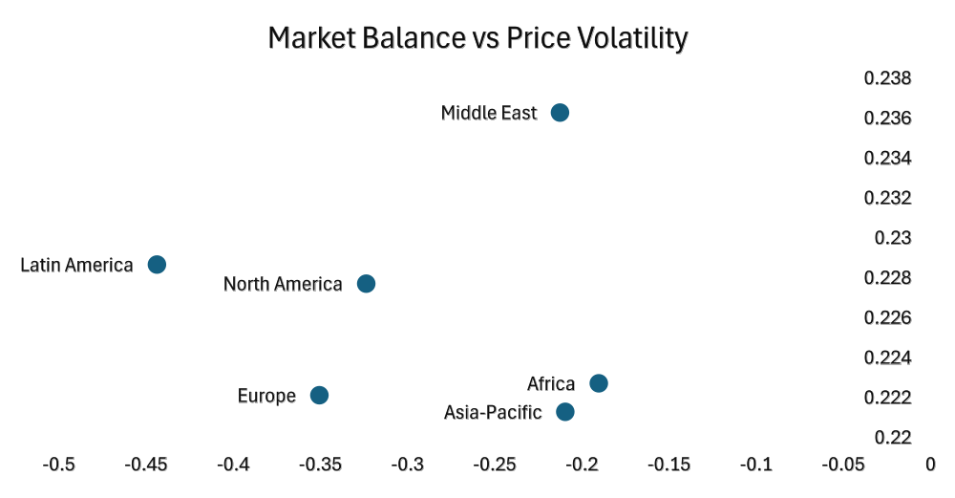

Figure 6. Market Balance vs Price Volatility
The scatter plot shows a clear negative relationship between market balance and price volatility. Regions with stronger market balance scores tend to exhibit lower volatility, reflecting more stable supply–demand conditions. Conversely, regions with weaker balance scores show higher volatility, often driven by supply constraints, import dependence, or exposure to shock events.

8. Summary of Insights
The dataset reveals several consistent patterns:
- Fossil fuels exhibit higher volatility than renewables.
- Asia-Pacific drives global demand, while the Middle East drives exports.
- Renewable adoption is increasing but uneven across regions.
- Shock events significantly influence volatility and market balance.
- Supply–demand gaps are a strong predictor of market stability.
These insights support strategic planning, risk assessment, and long-term energy policy development.

TECHNICAL APPENDIX
Energy Market Dataset – Methodology and Technical Documentation

1. Overview
This Technical Appendix provides a detailed explanation of the methodology used to generate, structure, and validate the synthetic energy market dataset used in the accompanying briefing note. It outlines the data-generation logic, variable definitions, assumptions, and reproducibility steps to ensure transparency and analytical rigour.

2. Data Generation Methodology
2.1 Approach
A Python script was used to generate a structured dataset simulating global energy market behaviour over a three-year period. The script programmatically created 504 observations by combining:
- 12 quarters
- 6 regions
- 7 energy types
Each row represents a unique combination of quarter, region, and energy type.
2.2 Tools Used
- Python 3.13
- Pandas 2.3.2
- VS Code (for script execution and file management)
2.3 Script Logic Summary
The script follows these steps:
- Define categorical dimensions
  - Quarters (Q1–Q4 across 3 years)
  - Regions
  - Energy types
- Assign base values
Each energy type has a realistic base price (e.g., oil ≈ $70, LNG ≈ $9, solar ≈ $42).
- Introduce controlled randomness
Random variation is applied to simulate real-world fluctuations in:
  - Price
  - Production
  - Consumption
  - Imports/exports
  - Storage levels
  - Renewable share
  - Volatility
  - Market balance
- Generate shock indicators
Binary variables (0/1) simulate:
- Geopolitical events
- Extreme weather
- Regulatory changes
- Supply chain disruptions
- Calculate derived variables
- Supply–demand gap = production − consumption
- Market balance index = (exports − imports) / 100
- Export the dataset
- CSV file
- JSON file

3. Variable Definitions
Variable | Description
quarter | Time period (Q1–Q4 across 3 years)
region | Geographic region (6 total)
energy_type | Energy category (7 types)
price_usd_per_unit | Simulated market price per unit
production_volume | Units produced in the quarter
consumption_volume | Units consumed in the quarter
import_volume | Imported units
export_volume | Exported units
storage_level | Storage percentage (45–85%)
renewable_share | Renewable percentage (10–30%)
supply_demand_gap | Production minus consumption
price_volatility_index | Volatility score (0.10–0.35)
market_balance_index | (Exports − imports) / 100
geopolitical_event | 1 = geopolitical event occurred
extreme_weather | 1 = extreme weather event occurred
regulatory_change | 1 = regulatory change occurred
supply_chain_disruption | 1 = supply chain disruption occurred

4. Assumptions
4.1 Market Behaviour
- Prices fluctuate within realistic ranges for each energy type.
- Production and consumption vary by region and quarter.
- Renewable share increases gradually over time.
- Shock events occur infrequently but impact volatility.
4.2 Regional Dynamics
- Middle East has higher export volumes.
- Asia-Pacific shows higher production/consumption.
- Europe and North America have higher renewable shares.
4.3 Data Integrity
- No missing values are generated.
- All variables fall within controlled ranges.

5. Validation Steps
5.1 Structural Validation
- Confirmed 504 rows (12 × 6 × 7).
- Verified all 17 variables appear in each row.
- Ensured CSV and JSON files exported correctly.
5.2 Range Checks
- Prices fall within expected ranges for each energy type.
- Storage levels remain between 45–85%.
- Renewable share remains between 10–30%.
- Volatility index remains between 0.10–0.35.
5.3 Logical Consistency
- Supply–demand gap correctly calculated.
- Market balance index reflects import/export differences.
- Shock indicators are binary (0 or 1).

6. Limitations
- Dataset is synthetic and does not represent real market data.
- Shock events are randomly assigned rather than historically grounded.
- Long-term structural changes (e.g., policy shifts, technology adoption) are not modelled.
- Regional behaviour is simplified for clarity.

7. Reproducibility
The dataset can be regenerated at any time by running the Python script.
To reproduce:
- Install Python and pandas
- Save the script as generate_dataset.py
- Run:
python generate_dataset.py
- CSV and JSON files will be created automatically.

8. File Outputs
- energy_market_dataset.csv
- energy_market_dataset.json
Both files contain identical data in different formats for flexibility.

9. Conclusion
This Technical Appendix provides full transparency into the dataset’s construction, assumptions, and validation. The methodology ensures the dataset is structured, consistent, and suitable for analytical tasks, visualisation, and portfolio demonstration.

